Adjectives with suffix –Lİ , -LI, -LU, -LÜ (WITH)  The above suffixes are always added to a noun according to the vowel harmony. These nouns turn into adjectives with suffix –li, -lı, -lü, - lu .
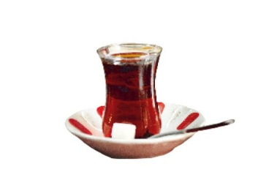
Şekerli çay (tea with sugar)
Susamlı simit (bagel with sesame) 
Buzlu ve limonlu çay (tea with ice and lemon) 
Yoğurtlu kebap (kebap with yoghurt ) 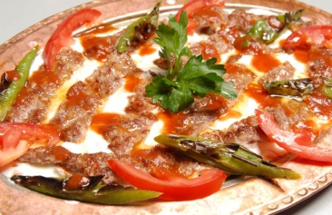
Meyveli ağaç (tree with fruit ) 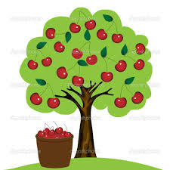
(Turkish proverb : ‘ Meyveli ağaç taşlanır ‘ A fruit tree is thrown stone
If there is something good anywhere , everybody wants to catch or have it in a way )
Mavi gözlü çocuk ( the boy with blue eyes) 

Çiçekli bahçe (garden with flowers) 2
Akıllı kız ( smart girl)
Sözlü sunum (oral presentation)
Evli çift (married couple)
İzinli öğrenci ( student been let / given permission to go out)
Diplomalı işsiz ( the unemployed with diploma)
Sebzeli tavuk (chicken cooked with vegetable)
Etli yemek ( meal cooked with meat)
Mobilyalı ev (furnished flat or house)
Eşyalı ev (furnished flat or house)
Bahçeli ev (house with garden)
Kırmızı elbiseli kadın (woman with red dress)
Uzun boylu adam (tall man)
Kısa saçlı kadın ( woman with short hair)
Nemli hava ( wet air )
Tehlikeli iş ( dangerous job , work or situation)
Rüzgarlı ve dalgalı deniz ( windy and wavy sea)
Peynirli poğaca or börek (pastry with cheese)
Acılı kebab , yemek ( meal with hot spice )
Adjectives with suffix -sız , siz, suz , süz ( without) Şekersiz çay ( tea without sugar ) 
Evsiz adam (homeless man) Uykusuz gece ( night without sleep) Kafasız adam ( man with no head or brain , absent-minded man)
İçkisiz restoran (restaurant in which alcoholic drink is not served) Teacher2015

